KENDRIYA VIDYALAYA ONGC

PANVEL



A PROJECT REPORT ON

CYBER-CAFE MANGEMENT

KENDRIYA VIDYALAYA ONGCPANVEL

SUBMITTED BY:

ANIKET PAWAR

CLASS: XII-A

SUBMITTED TO:

MRS. SHRUTI SHRIVASTAVA

P.G.T.(COMP. SC)

CERTIFICATE

This is to certify that **Aniket Sharad Pawar** of class **XII**

**A** of **Kendriya Vidyalaya ONGC Panvel** has done her project on **CYBER-CAFE MANGEMENT** under my supervision. He has taken interest and has shown at most sincerity in completion of this project. I certify this Project up to my expectation & as per guidelines

issued by **CBSE**.

*Internal Examiner External Examiner*

*Principal School Stamp*

ACKNOWLEDGMENT

It is with pleasure that I acknowledge my sincere gratitude to our teacher, **MRS. SHRUTI SHRIVASTAVA** who taught and undertook the responsibility of teaching the subject computer science. I have been greatly benefited from his classes.

I am especially indebted to our Principal **MR.SOHON LAL.**

who has always been a source of encouragement and support and without whose inspiration this project would not have been a successful I would like to place on record heartfelt thanks to him.

Finally, I would like to express my sincere appreciation for all the other students for my batch their friendship & the fine times that we all shared together.

INDEX

|  |  |  |
| --- | --- | --- |
| S.No. | Description | Page No. |
| 1. | **Introduction** |  |
| 2. | **Requirements (hardware & software)** |  |
| 3. | **Flow Chart** |  |
| 3. | **Database Table structures** |  |
| 4. | **Python Source code** |  |
| 5. | **Output Screens** |  |
| 6. | **Bibliography** |  |

Introduction

Introduction Cyber Café Management is a complete package developed for management of systems in a cyber café. This project is intended to be used in a Cyber Café. All cyber cafes have some basic needs likeable to control the systems that are being rented to the customers and are charged on timely basis. A Cyber café normally has some number of PC’s which the customers will for certain amount of time.

Now days it may also require to save some details of the customers for security reasons. When a customer enters a cyber café he has to be allotted a PC and the start time is noted. It should be recorded. And finally all the details will be available to the Cyber administrator. And he can submit on the form to generate the bill. There should be displays of all the transactions taking place in the café.

HARDWARE AND SOFTWARE REQUIRED

**HARDWARE**:

Processor – Intel core i5-8265U CPU 1.60 – 1.80

GHz

RAM – 64 MB Hard-disc – 20 GB

Printer – To print the documents of the project

**SOFTWARE**:

Operating system – Windows 10

Language – Python 3.8

Database – MySQL 8.0

MS Word – For presentation of project

FLOW CHART

Start

Login

Bills

Create Bill

Customer info

Bills

Bill

List of Customers

Add new Customers

Update Customer Detail

Exit

Delete Customers Detail

DATABASE TABLE STRUCTURE

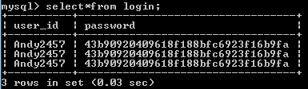

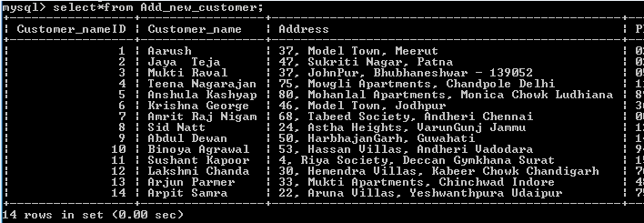

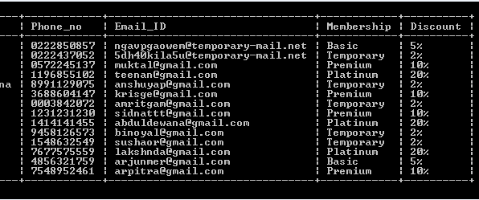

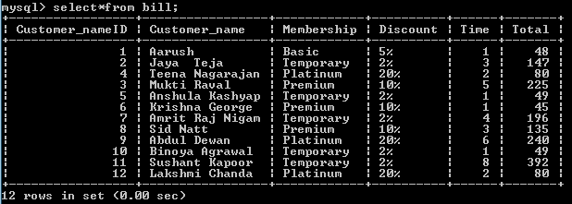

CODING

1)tkinter cyber…..py

from tkinter.ttk import *

import tkinter

from tkinter import *

import os

import mysql.connector as mycon

from tkinter import messagebox

import hashlib

import winsound

from PIL import ImageTk, Image

count=1

chance=2

cn = mycon.connect(host='localhost',user='root',passwd="tiger")

cur = cn.cursor()

cur.execute("create database if not exists Cyber_cafe")

cur.execute("use Cyber_cafe")

cur.execute("create table if not exists login (user_id varchar(2000),password varchar(2000))")

cur.execute("insert into login values ('Andy2457',md5('tiger'))")

cur.execute("create table if not exists loginhistory (user_id varchar(2000),Details varchar(2000))")

cn.commit()

cur.execute("select*from login")

c=cur.fetchone()

def login():

global count

global chance

global c,cp,u

u=userr.get()

p=pasw.get()

result = hashlib.md5(p.encode())

cp=result.hexdigest()

if u=="":

messagebox.showinfo("CCM","Please Enter User ID")

elif p=="":

messagebox.showinfo("CCM","Please Enter Password")

elif u==c[0] and cp==c[1]:

winsound.PlaySound(r'1\sound\loginsucessful.wav',winsound.SND_ALIAS | winsound.SND_ASYNC)

messagebox.showinfo("CCM","| Login Sucessful |")

win.destroy()

os.system("python layer2.py")

else:

messagebox.showinfo("CCM","Please Enter Correct UserID and Password")

def qui():

win.destroy()

exit()

win=Tk()

win.title('CCB')

win.geometry("380x270+300+200")

bg=PhotoImage(file=r"1\images\bg.png")

labelforimage=tkinter.Label(win,image=bg)

labelforimage.pack()

win.resizable(False,False)

l1=tkinter.Label(win,text="CYBER_CAFE MANAGEMENT",fg="brown",bg="white",font=("The Poster King",20))

l1.place(x=60,y=5)

user=PhotoImage(file=r"1\images\logo1.png")

userr=StringVar()

pasw=StringVar()

l2=tkinter.Label(win,image=user)

l2.place(x=90,y=40)

l3=tkinter.Label(win,text="User ID",fg="blue",bg="white",font=("Cambria",12))

l3.place(x=60,y=160)

l4=tkinter.Label(win,text="Password",fg="blue",bg="white",font=("Cambria",12))

l4.place(x=50,y=190)

e1=tkinter.Entry(win,textvariable=userr,fg="white",bg="black")

e1.place(x=150,y=162)

e2=tkinter.Entry(win,textvariable=pasw,show="•",fg="white",bg="black")

e2.place(x=150,y=192)

ex=PhotoImage(file=r"1\images\exet.png")

b2=ttk.Button(win,image=ex,command=qui)

b2.place(x=340,y=180)

log=PhotoImage(file=r"1\images\log.png")

b3=ttk.Button(win,image=log,command=login)

b3.place(x=155,y=220)

win.mainloop()

1. layer2.py

from tkinter.ttk import *

from tkinter import*

import tkinter

import os

from tkinter import messagebox

import random

import tkinter.font as font

win=Tk()

win.title('CCM')

win.geometry("900x600")

bg=PhotoImage(file=r"1\images\bg2.png")

labelforimage=tkinter.Label(win,image=bg)

labelforimage.place(x=580,y=10)

bg1=PhotoImage(file=r"1\images\bg1.png")

b1=tkinter.Label(win,image=bg1)

b1.place(x=450,y=250)

win.config(bg="Peru")

win.resizable(False,False)

l1=tkinter.Label(win,text="CYBER_CAFE",fg="black",bg="Peru",font=("The Poster King",50))

l1.place(x=89,y=5)

l2=tkinter.Label(win,text="MANAGEMENT",fg="black",bg="Peru",font=("The Poster King",50))

l2.place(x=80,y=100)

def customerinfo():

win.destroy()

os.system("python cinfo.py")

def bill():

win.destroy()

os.system("python bill.py")

def bills():

os.system("python Bills.py")

def ex():

win.destroy()

exit()

myfont=font.Font(family='LingLengLang',size=40)

b1=Button(win,text="CUSTOMER INFO",fg='brown',font=myfont,command=customerinfo)

b1.place(x=10,y=200)

b2=Button(win,text="CREATE BILL",fg='brown',font=myfont,command=bill)

b2.place(x=10,y=300)

b2=Button(win,text="BILLS",fg='brown',font=myfont,command=bills)

b2.place(x=10,y=400)

b4=Button(win,text="EXIT",fg='brown',font=myfont,command=ex)

b4.place(x=10,y=500)

win.mainloop()

1. all.py

from tkinter.ttk import *

from tkinter import*

import tkinter

import os

from tkinter import messagebox

import tkinter.font as font

import mysql.connector as sql

conn=sql.connect(host ='localhost',user ='root',password ='tiger')

c1=conn.cursor()

win=Tk()

win.title('CCM')

win.geometry("1350x600")

win.config(bg="Peru")

win.resizable(False,False)

l1=tkinter.Label(win,text="CYBER_CAFE MANAGEMENT",fg="black",bg="Peru",font=("The Poster King",50))

l1.grid(row=0, columnspan=3)

c1.execute("use Cyber_Cafe")

c1.execute("select * from Add_new_customer")

output=c1.fetchall()

l2=tkinter.Label(win,text="Customer Info",fg="black",bg="peru",font=("LingLengLang",40)).grid(row=1, columnspan=4)

cols = ('Customer ID', 'Customer Name', 'Address', 'Mobile No.', 'Email ID', 'Membership', 'Discount')

listBox = ttk.Treeview(win, columns=cols, show='headings')

for col in cols:

listBox.heading(col, text=col)

listBox.grid(row=2, column=0, columnspan=2)

for c in output:

listBox.insert("","end",values=(c[0],c[1],c[2],c[3],c[4],c[5],c[6]))

win.mainloop()

1. cinfo.py

from tkinter.ttk import *

from tkinter import*

import tkinter

import os

from tkinter import messagebox

import tkinter.font as font

import mysql.connector as sql

win=Tk()

win.title('CCM')

win.geometry("900x600")

bg=PhotoImage(file=r"1\images\bg2.png")

labelforimage=tkinter.Label(win,image=bg)

labelforimage.place(x=580,y=10)

bg1=PhotoImage(file=r"1\images\bg1.png")

b1=tkinter.Label(win,image=bg1)

b1.place(x=450,y=250)

win.config(bg="Peru")

win.resizable(False,False)

l1=tkinter.Label(win,text="CYBER_CAFE",fg="black",bg="Peru",font=("The Poster King",50))

l1.place(x=89,y=5)

l2=tkinter.Label(win,text="MANAGEMENT",fg="black",bg="Peru",font=("The Poster King",50))

l2.place(x=80,y=100)

def addc():

win.destroy()

os.system("python add.py")

def update():

win.destroy()

os.system("python update.py")

def dele():

win.destroy()

os.system("python delete.py")

def allc():

os.system("python all.py")

def ex():

win.destroy()

exit()

def back():

win.destroy()

os.system("python layer2.py")

myfont=font.Font(family='LingLengLang',size=30)

b1=Button(win,text="LIST OF CUSTOMERS",fg='brown',font=myfont,command=allc)

b1.place(x=10,y=200)

b2=Button(win,text="ADD NEW CUSTOMER",fg='brown',font=myfont,command=addc)

b2.place(x=10,y=270)

b3=Button(win,text="UPDATE CUSTOMER DETAILS",fg='brown',font=myfont,command=update)

b3.place(x=10,y=340)

b3=Button(win,text="DELETE CUSTOMER DETAILS",fg='brown',font=myfont,command=dele)

b3.place(x=10,y=410)

b4=Button(win,text="EXIT",fg='brown',font=myfont,command=ex)

b4.place(x=10,y=500)

b5=Button(win,text='BACK',fg='brown',font=myfont,command=back).place(x=300,y=500)

win.mainloop()

1. add.py

from tkinter.ttk import *

from tkinter import*

import tkinter

import os

from tkinter import messagebox

import tkinter.font as font

import mysql.connector as sql

conn=sql.connect(host ='localhost',user ='root',password ='tiger')

c1=conn.cursor()

c1.execute('create database if not exists Cyber_Cafe')

c1.execute('use Cyber_Cafe')

c1.execute('create table if not exists Add_new_customer(Customer_nameID int(100),Customer_name varchar(20),Address varchar(100),Phone_no varchar(12),Email_ID varchar(40),Membership varchar(50),Discount varchar(10))')

win=Tk()

win.title('CCM')

win.geometry("900x700")

bg=PhotoImage(file=r"1\images\bg2.png")

labelforimage=tkinter.Label(win,image=bg)

labelforimage.place(x=580,y=10)

win.config(bg="Peru")

win.resizable(False,False)

l1=tkinter.Label(win,text="CYBER_CAFE",fg="black",bg="Peru",font=("The Poster King",50))

l1.place(x=89,y=5)

l2=tkinter.Label(win,text="MANAGEMENT",fg="black",bg="Peru",font=("The Poster King",50))

l2.place(x=80,y=100)

l3=tkinter.Label(win,text="Add New Customers",fg="brown",bg="Peru",font=("The Poster King",30))

l3.place(x=100,y=200)

count=0

def discc():

m=membership.get()

if m=="Select":

messagebox.showinfo("CCM","Please Select Membership First")

elif m=="Temporary":

discount.set("2%")

elif m=="Basic":

discount.set("5%")

elif m=="Premium":

discount.set("10%")

elif m=="Platinum":

discount.set("20%")

def reset():

customerid.set("")

name.set("")

address.set("")

phone.set("")

email.set("")

membership.set("Select")

discount.set("")

def add():

c=customerid.get()

n=name.get()

a=address.get()

p=phone.get()

m=membership.get()

e=email.get()

d=discount.get()

if c=="":

messagebox.showinfo("CCM","Please Generate ID")

elif n=="":

messagebox.showinfo("CCM","Please Enter Name")

elif a=="":

messagebox.showinfo("CCM","Please Enter Address")

elif p=="":

messagebox.showinfo("CCM","Please Enter Mobile Number")

elif e=="":

messagebox.showinfo("CCM","Please Select Email Address")

elif m=="Select":

messagebox.showinfo("CCM","Please Select Membership")

elif d=="":

messagebox.showinfo("CCM","Please Check Discount")

else:

if len(p)==10:

if m=="Temporary":

d="2%"

elif m=="Basic":

d="5%"

elif m=="Premium":

d="10%"

elif m=="Platinum":

d="20%"

c1.execute("insert into Add_new_customer values ("+str(c)+",'"+str(n)+"','"+str(a)+"','"+str(p)+"','"+str(e)+"','"+str(m)+"','"+str(d)+"')")

conn.commit()

win.destroy()

messagebox.showinfo("CCM","Entered Successfully.")

os.system("python cinfo.py")

else:

messagebox.showinfo("CCM","Please Enter Valid Mobile No.")

def back():

win.destroy()

os.system("python cinfo.py")

def generateid():

global count

customerid.set(str(count+1))

customerid=StringVar()

name=StringVar()

address=StringVar()

phone=StringVar()

email=StringVar()

membership=StringVar()

discount=StringVar()

c1.execute("select * from Add_new_customer")

result=c1.fetchall()

for i in result:

count+=1

sett=count+1

l2=tkinter.Label(win,text="Customer ID :",fg="white",bg="peru",font=("Constantia",20,'bold')).place(x=20,y=250)

l3=tkinter.Label(win,text="Name:",fg="white",bg="peru",font=("Constantia",20,'bold')).place(x=20,y=300)

l4=tkinter.Label(win,text="Address:",fg="white",bg="peru",font=("Constantia",20,'bold')).place(x=20,y=350)

l5=tkinter.Label(win,text="Phone no.:",fg="white",bg="peru",font=("Constantia",20,'bold')).place(x=20,y=400)

l8=tkinter.Label(win,text="Email Address:",fg="white",bg="peru",font=("Constantia",20,'bold')).place(x=20,y=450)

l6=tkinter.Label(win,text="Membership:",fg="white",bg="peru",font=("Constantia",20,'bold')).place(x=20,y=500)

l7=tkinter.Label(win,text="Discount:",fg="white",bg="peru",font=("Constantia",20,'bold')).place(x=20,y=550)

idd=ttk.Entry(win,state="readonly:",textvariable=customerid).place(x=220,y=250,width=300,height=40)

b1=ttk.Button(win,text="Generate ID:",command=generateid).place(x=600,y=250,width=200,height=40)

nme=ttk.Entry(win,textvariable=name,state="normal").place(x=220,y=300,width=300,height=40)

ad=ttk.Entry(win,textvariable=address,state="normal").place(x=220,y=350,width=300,height=40)

ead=ttk.Entry(win,textvariable=email,state="normal").place(x=220,y=450,width=300,height=40)

mn=ttk.Entry(win,textvariable=phone,state="normal").place(x=220,y=400,width=300,height=40)

mship=ttk.OptionMenu(win,membership,"Select","Temporary","Basic","Premium","Platinum").place(x=220,y=500,width=300,height=40)

disc=ttk.Entry(win,textvariable=discount,state="readonly").place(x=220,y=550,width=300,height=40)

b5=ttk.Button(win,text="Check Discount",command=discc).place(x=600,y=550,width=200,height=40)

b2=ttk.Button(win,text='BACK',command=back).place(x=450,y=600,width=100,height=40)

b3=ttk.Button(win,text='ADD',command=add).place(x=300,y=600,width=100,height=40)

b4=ttk.Button(win,text='RESET',command=reset).place(x=150,y=600,width=100,height=40)

win.mainloop()

1. update.py

from tkinter.ttk import *

from tkinter import*

import tkinter

import os

from tkinter import messagebox

import tkinter.font as font

import mysql.connector as sql

conn=sql.connect(host ='localhost',user ='root',password ='tiger')

c1=conn.cursor()

c1.execute('create database if not exists Cyber_Cafe')

c1.execute('use Cyber_Cafe')

c1.execute('create table if not exists Add_new_customer(Customer_nameID int(100),Customer_name varchar(20),Address varchar(100),Phone_no varchar(12),Email_ID varchar(40),Membership varchar(50),Discount varchar(10))')

win=Tk()

win.title('CCM')

win.geometry("900x700")

bg=PhotoImage(file=r"1\images\bg2.png")

labelforimage=tkinter.Label(win,image=bg)

labelforimage.place(x=580,y=10)

win.config(bg="Peru")

win.resizable(False,False)

l1=tkinter.Label(win,text="CYBER_CAFE",fg="black",bg="Peru",font=("The Poster King",50))

l1.place(x=89,y=5)

l2=tkinter.Label(win,text="MANAGEMENT",fg="black",bg="Peru",font=("The Poster King",50))

l2.place(x=80,y=100)

l3=tkinter.Label(win,text="Update The Data",fg="brown",bg="Peru",font=("The Poster King",30))

l3.place(x=100,y=200)

count=0

def discc():

m=membership.get()

if m=="Select":

messagebox.showinfo("CCM","Please Select Membership First")

elif m=="Temporary":

discount.set("2%")

elif m=="Basic":

discount.set("5%")

elif m=="Premium":

discount.set("10%")

elif m=="Platinum":

discount.set("20%")

def reset():

customerid.set("")

name.set("")

address.set("")

phone.set("")

email.set("")

membership.set("Select")

discount.set("")

def add():

c=customerid.get()

n=name.get()

a=address.get()

p=phone.get()

m=membership.get()

e=email.get()

d=discount.get()

if c=="":

messagebox.showinfo("CCM","Please Generate ID")

elif n=="":

messagebox.showinfo("CCM","Please Enter Name")

elif a=="":

messagebox.showinfo("CCM","Please Enter Address")

elif p=="":

messagebox.showinfo("CCM","Please Enter Mobile Number")

elif e=="":

messagebox.showinfo("CCM","Please Select Email Address")

elif m=="Select":

messagebox.showinfo("CCM","Please Select Membership")

elif d=="":

messagebox.showinfo("CCM","Please Check Discount")

else:

if len(p)==10:

if m=="Temporary":

d="2%"

elif m=="Basic":

d="5%"

elif m=="Premium":

d="10%"

elif m=="Platinum":

d="20%"

c1.execute("insert into Add_new_customer values ("+str(c)+",'"+str(n)+"','"+str(a)+"','"+str(p)+"','"+str(e)+"','"+str(m)+"','"+str(d)+"')")

conn.commit()

win.destroy()

messagebox.showinfo("CCM","Entered Successfully.")

os.system("python cinfo.py")

else:

messagebox.showinfo("CCM","Please Enter Valid Mobile No.")

def back():

win.destroy()

os.system("python cinfo.py")

def generateid():

global count

customerid.set(str(count+1))

customerid=StringVar()

name=StringVar()

address=StringVar()

phone=StringVar()

email=StringVar()

membership=StringVar()

discount=StringVar()

c1.execute("select * from Add_new_customer")

result=c1.fetchall()

for i in result:

count+=1

sett=count+1

l2=tkinter.Label(win,text="Customer ID :",fg="white",bg="peru",font=("Constantia",20,'bold')).place(x=20,y=250)

l3=tkinter.Label(win,text="Name:",fg="white",bg="peru",font=("Constantia",20,'bold')).place(x=20,y=300)

l4=tkinter.Label(win,text="Address:",fg="white",bg="peru",font=("Constantia",20,'bold')).place(x=20,y=350)

l5=tkinter.Label(win,text="Phone no.:",fg="white",bg="peru",font=("Constantia",20,'bold')).place(x=20,y=400)

l8=tkinter.Label(win,text="Email Address:",fg="white",bg="peru",font=("Constantia",20,'bold')).place(x=20,y=450)

l6=tkinter.Label(win,text="Membership:",fg="white",bg="peru",font=("Constantia",20,'bold')).place(x=20,y=500)

l7=tkinter.Label(win,text="Discount:",fg="white",bg="peru",font=("Constantia",20,'bold')).place(x=20,y=550)

idd=ttk.Entry(win,state="readonly:",textvariable=customerid).place(x=220,y=250,width=300,height=40)

b1=ttk.Button(win,text="Generate ID:",command=generateid).place(x=600,y=250,width=200,height=40)

nme=ttk.Entry(win,textvariable=name,state="normal").place(x=220,y=300,width=300,height=40)

ad=ttk.Entry(win,textvariable=address,state="normal").place(x=220,y=350,width=300,height=40)

ead=ttk.Entry(win,textvariable=email,state="normal").place(x=220,y=450,width=300,height=40)

mn=ttk.Entry(win,textvariable=phone,state="normal").place(x=220,y=400,width=300,height=40)

mship=ttk.OptionMenu(win,membership,"Select","Temporary","Basic","Premium","Platinum").place(x=220,y=500,width=300,height=40)

disc=ttk.Entry(win,textvariable=discount,state="readonly").place(x=220,y=550,width=300,height=40)

b5=ttk.Button(win,text="Check Discount",command=discc).place(x=600,y=550,width=200,height=40)

b2=ttk.Button(win,text='BACK',command=back).place(x=450,y=600,width=100,height=40)

b3=ttk.Button(win,text='ADD',command=add).place(x=300,y=600,width=100,height=40)

b4=ttk.Button(win,text='RESET',command=reset).place(x=150,y=600,width=100,height=40)

win.mainloop()

1. delete.py

from tkinter.ttk import *

from tkinter import*

import tkinter

import os

from tkinter import messagebox

import tkinter.font as font

import mysql.connector as sql

conn=sql.connect(host ='localhost',user ='root',password ='tiger')

c1=conn.cursor()

c1.execute('create database if not exists Cyber_Cafe')

c1.execute('use Cyber_Cafe')

c1.execute('create table if not exists Add_new_customer(Customer_nameID int(100),Customer_name varchar(20),Address varchar(100),Phone_no varchar(12),Email_ID varchar(40),Membership varchar(50),Discount varchar(10))')

win=Tk()

win.title('CCM')

win.geometry("900x700")

bg=PhotoImage(file=r"1\images\bg2.png")

labelforimage=tkinter.Label(win,image=bg)

labelforimage.place(x=580,y=10)

win.config(bg="Peru")

win.resizable(False,False)

l1=tkinter.Label(win,text="CYBER_CAFE",fg="black",bg="Peru",font=("The Poster King",50))

l1.place(x=89,y=5)

l2=tkinter.Label(win,text="MANAGEMENT",fg="black",bg="Peru",font=("The Poster King",50))

l2.place(x=80,y=100)

l3=tkinter.Label(win,text="Delete",fg="brown",bg="Peru",font=("The Poster King",30))

l3.place(x=100,y=200)

count=0

globalid=0

def reset():

customerid.set("")

name.set("")

address.set("")

phone.set("")

email.set("")

membership.set("")

discount.set("")

def back():

win.destroy()

os.system("python cinfo.py")

def find():

idd=int(customerid.get())

globalid=idd

if idd>count:

messagebox.showinfo("CCM","No Such Customer")

customerid.set("")

name.set("")

address.set("")

phone.set("")

email.set("")

membership.set("")

discount.set("")

else:

win.geometry("900x700")

c1.execute("select * from Add_new_customer")

result=c1.fetchall()

for i in result:

if str(i[0])==str(idd):

customerid.set(str(idd))

name.set(str(i[1]))

address.set(str(i[2]))

phone.set(str(i[3]))

email.set(str(i[4]))

membership.set(str(i[5]))

discount.set(str(i[6]))

def dele():

ans=messagebox.askquestion("RMS","Are You Sure To Delete")

if ans=="yes":

idd=customerid.get()

c1.execute("delete from Add_new_customer where Customer_nameID="+str(idd))

conn.commit()

messagebox.showinfo("CCM","Operation Sucessful")

win.destroy()

os.system("python cinfo.py")

customerid=StringVar()

name=StringVar()

address=StringVar()

phone=StringVar()

email=StringVar()

membership=StringVar()

discount=StringVar()

c1.execute("select * from Add_new_customer")

result=c1.fetchall()

for i in result:

count+=1

sett=count+1

b1=ttk.Button(win,text="Find",command=find).place(x=600,y=250,width=200,height=40)

l2=tkinter.Label(win,text="Customer ID :",fg="white",bg="peru",font=("Constantia",20,'bold')).place(x=20,y=250)

l3=tkinter.Label(win,text="Name:",fg="white",bg="peru",font=("Constantia",20,'bold')).place(x=20,y=300)

l4=tkinter.Label(win,text="Address:",fg="white",bg="peru",font=("Constantia",20,'bold')).place(x=20,y=350)

l5=tkinter.Label(win,text="Phone no.:",fg="white",bg="peru",font=("Constantia",20,'bold')).place(x=20,y=400)

l8=tkinter.Label(win,text="Email Address:",fg="white",bg="peru",font=("Constantia",20,'bold')).place(x=20,y=450)

l6=tkinter.Label(win,text="Membership:",fg="white",bg="peru",font=("Constantia",20,'bold')).place(x=20,y=500)

l7=tkinter.Label(win,text="Discount:",fg="white",bg="peru",font=("Constantia",20,'bold')).place(x=20,y=550)

idd=ttk.Entry(win,state="normal",textvariable=customerid).place(x=220,y=250,width=300,height=40)

nme=ttk.Entry(win,textvariable=name,state="readonly").place(x=220,y=300,width=300,height=40)

ad=ttk.Entry(win,textvariable=address,state="readonly").place(x=220,y=350,width=300,height=40)

ead=ttk.Entry(win,textvariable=email,state="readonly").place(x=220,y=450,width=300,height=40)

mn=ttk.Entry(win,textvariable=phone,state="readonly").place(x=220,y=400,width=300,height=40)

mship=ttk.Entry(win,textvariable=membership,state="readonly").place(x=220,y=500,width=300,height=40)

disc=ttk.Entry(win,textvariable=discount,state="readonly").place(x=220,y=550,width=300,height=40)

b2=ttk.Button(win,text='BACK',command=back).place(x=450,y=600,width=100,height=40)

b3=ttk.Button(win,text='DELETE',command=dele).place(x=300,y=600,width=100,height=40)

b4=ttk.Button(win,text='RESET',command=reset).place(x=150,y=600,width=100,height=40)

win.mainloop()

1. bill.py

from tkinter.ttk import *

from tkinter import*

import tkinter

import os

from tkinter import messagebox

import tkinter.font as font

import mysql.connector as sql

conn=sql.connect(host ='localhost',user ='root',password ='tiger')

c1=conn.cursor()

c1.execute('create database if not exists Cyber_Cafe')

c1.execute('use Cyber_Cafe')

c1.execute('create table if not exists Add_new_customer(Customer_nameID int(100),Customer_name varchar(20),Address varchar(100),Phone_no varchar(12),Email_ID varchar(40),Membership varchar(50),Discount varchar(10))')

c1.execute('create table if not exists Bill(Customer_nameID int(100),Customer_name varchar(20),Membership varchar(50),Discount varchar(10),Time int(100),Total int(100))')

win=Tk()

win.title('CCM')

win.geometry("900x700")

bg=PhotoImage(file=r"1\images\bg2.png")

labelforimage=tkinter.Label(win,image=bg)

labelforimage.place(x=580,y=10)

win.config(bg="Peru")

win.resizable(False,False)

l1=tkinter.Label(win,text="CYBER_CAFE",fg="black",bg="Peru",font=("The Poster King",50))

l1.place(x=89,y=5)

l2=tkinter.Label(win,text="MANAGEMENT",fg="black",bg="Peru",font=("The Poster King",50))

l2.place(x=80,y=100)

l3=tkinter.Label(win,text=" BILL",fg="brown",bg="Peru",font=("The Poster King",30))

l3.place(x=100,y=200)

count=0

globalid=0

def find():

idd=int(customerid.get())

globalid=idd

if idd>count:

messagebox.showinfo("CCM","No Such Customer")

customerid.set("")

name.set("")

membership.set("")

discount.set("")

else:

win.geometry("900x700")

c1.execute("select * from Add_new_customer")

result=c1.fetchall()

for i in result:

if str(i[0])==str(idd):

customerid.set(str(idd))

name.set(str(i[1]))

membership.set(str(i[5]))

discount.set(str(i[6]))

def back():

win.destroy()

os.system("python layer2.py")

def reset():

customerid.set("")

name.set("")

membership.set("")

discount.set("")

used.set("Select")

time.set("Select")

total.set("")

def total1():

d=(discount.get())

dis= int(str(d)[:-1])

a=int(time.get())

t=a*50-(a*50*(dis/100))

total.set(str(t))

def save():

c=customerid.get()

n=name.get()

m=membership.get()

d=discount.get()

t=time.get()

to=total.get()

c1.execute("insert Bill values ("+str(c)+",'"+str(n)+"','"+str(m)+"','"+str(d)+"','"+str(t)+"','"+str(to)+"')")

conn.commit()

win.destroy()

messagebox.showinfo("CCM","Entered Successfully.")

os.system("python layer2.py")

customerid=StringVar()

name=StringVar()

used=StringVar()

membership=StringVar()

time=StringVar()

discount=StringVar()

total=StringVar()

c1.execute("select * from Add_new_customer")

result=c1.fetchall()

for i in result:

count+=1

sett=count+1

b1=ttk.Button(win,text="Find",command=find).place(x=600,y=250,width=200,height=40)

l3=tkinter.Label(win,text="Customer ID :",fg="white",bg="peru",font=("Constantia",20,'bold')).place(x=20,y=250)

l4=tkinter.Label(win,text="Time Consumed:",fg="white",bg="peru",font=("Constantia",20,'bold')).place(x=20,y=300)

l5=tkinter.Label(win,text="Customer Name :",fg="white",bg="peru",font=("Constantia",20,'bold')).place(x=20,y=350)

l7=tkinter.Label(win,text="Membership:",fg="white",bg="peru",font=("Constantia",20,'bold')).place(x=20,y=400)

l9=tkinter.Label(win,text="Discount :",fg="white",bg="peru",font=("Constantia",20,'bold')).place(x=20,y=450)

l8=tkinter.Label(win,text="Total :",fg="white",bg="peru",font=("Constantia",20,'bold')).place(x=20,y=500)

idd=ttk.Entry(win,state="normal",textvariable=customerid).place(x=250,y=250,width=300,height=40)

mem=ttk.Entry(win,textvariable=membership,state="readonly").place(x=250,y=400,width=400,height=40)

tim=ttk.Entry(win,state="normal",textvariable=time).place(x=250,y=300,width=400,height=40)

disc=ttk.Entry(win,textvariable=discount,state="readonly").place(x=250,y=450,width=300,height=40)

tot=ttk.Entry(win,textvariable=total,state="readonly").place(x=250,y=500,width=300,height=40)

nme=ttk.Entry(win,textvariable=name,state="readonly").place(x=250,y=350,width=300,height=40)

b3=ttk.Button(win,text='Calculate',command=total1).place(x=600,y=500,width=200,height=40)

b2=ttk.Button(win,text='BACK',command=back).place(x=450,y=600,width=100,height=40)

b4=ttk.Button(win,text='RESET',command=reset).place(x=150,y=600,width=100,height=40)

b5=ttk.Button(win,text='SAVE',command=save).place(x=300,y=600,width=100,height=40)

win.mainloop()

1. Bills.py

from tkinter.ttk import *

from tkinter import*

import tkinter

import os

from tkinter import messagebox

import tkinter.font as font

import mysql.connector as sql

conn=sql.connect(host ='localhost',user ='root',password ='tiger')

c1=conn.cursor()

win=Tk()

win.title('CCM')

win.geometry("1200x600")

win.config(bg="Peru")

win.resizable(False,False)

l1=tkinter.Label(win,text="CYBER_CAFE MANAGEMENT",fg="black",bg="Peru",font=("The Poster King",50))

l1.grid(row=0, columnspan=3)

c1.execute("use Cyber_Cafe")

c1.execute("select * from Bill")

output=c1.fetchall()

l2=tkinter.Label(win,text="Bills",fg="black",bg="peru",font=("LingLengLang",40)).grid(row=1, columnspan=4)

cols = ('Customer ID', 'Customer Name', 'Membership', 'Discount', 'Time', 'Total')

listBox = ttk.Treeview(win, columns=cols, show='headings')

for col in cols:

listBox.heading(col, text=col)

listBox.grid(row=2, column=0, columnspan=2)

for c in output:

listBox.insert("","end",values=(c[0],c[1],c[2],c[3],c[4],c[5]))

win.mainloop()

OUTPUT

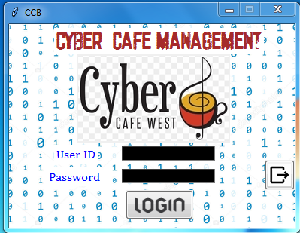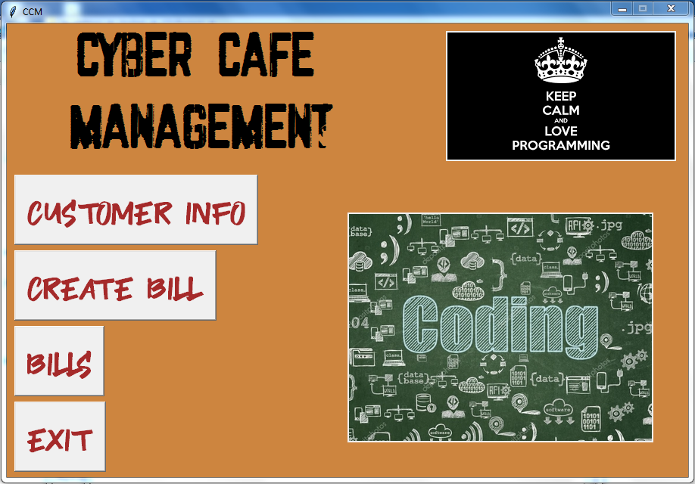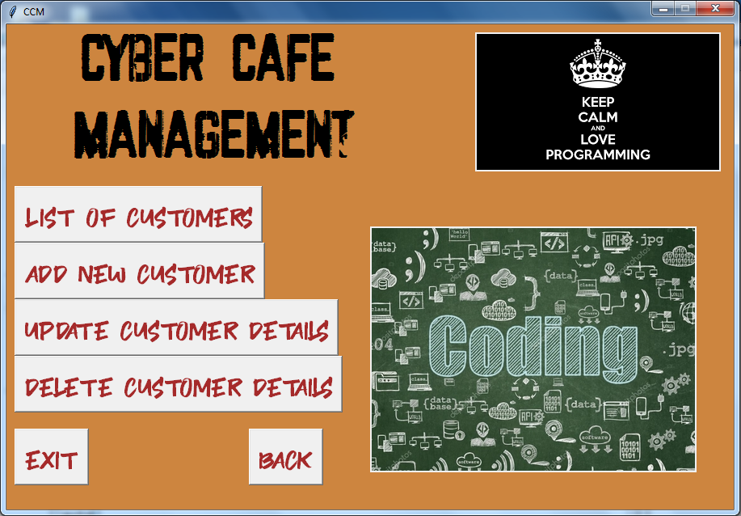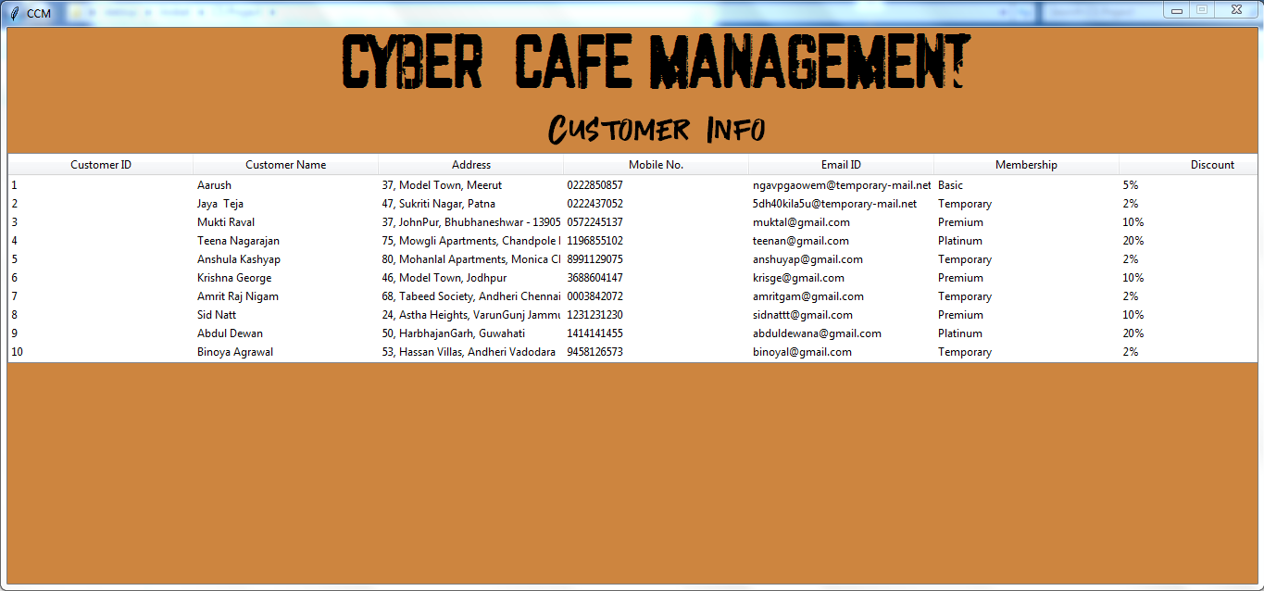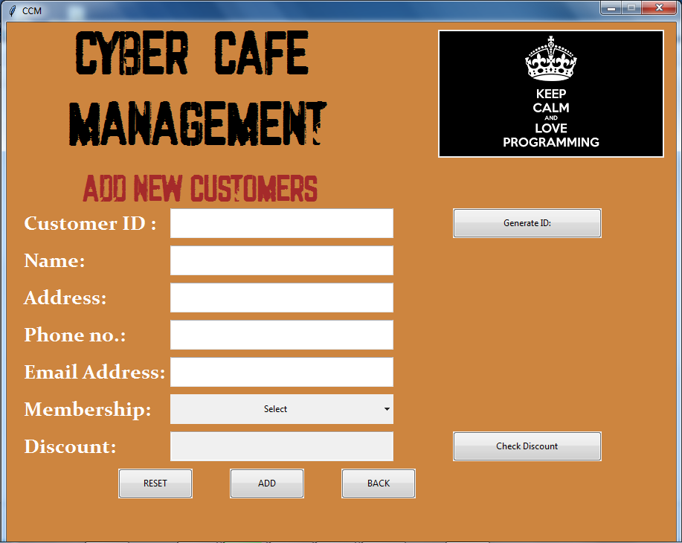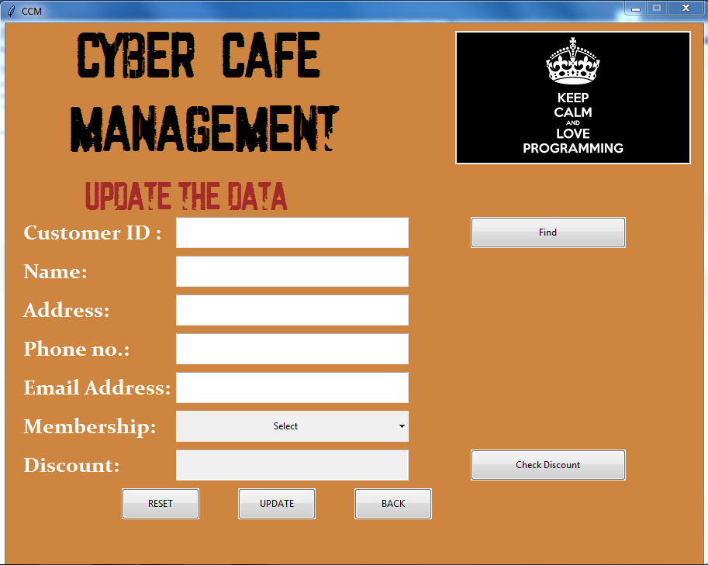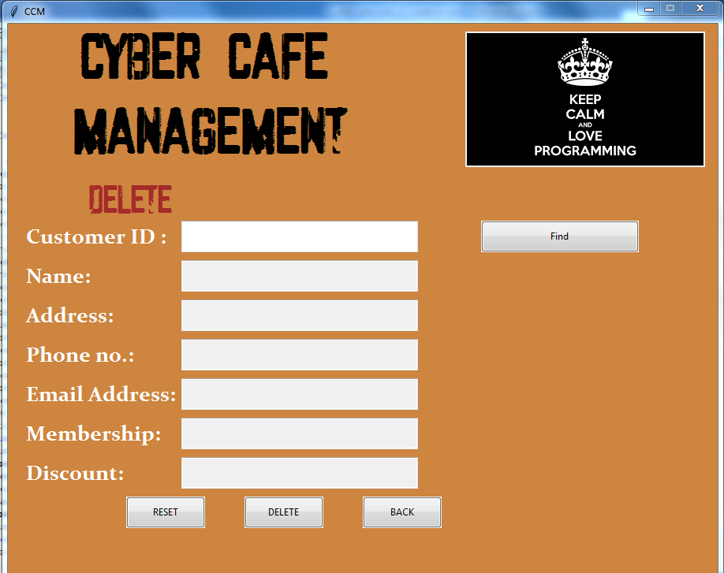

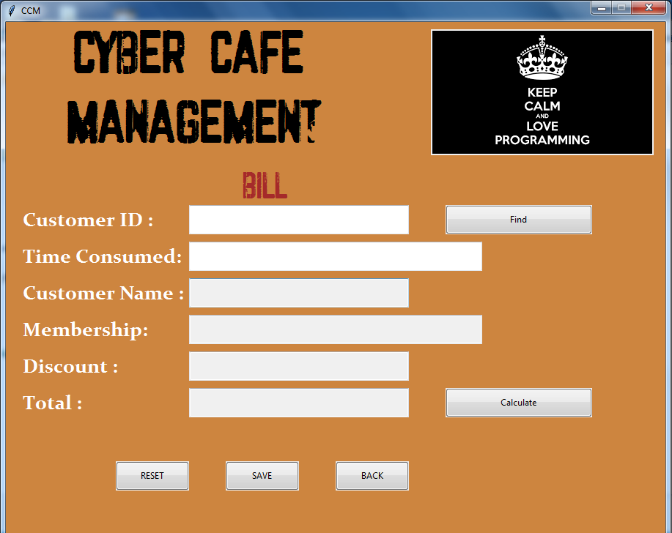

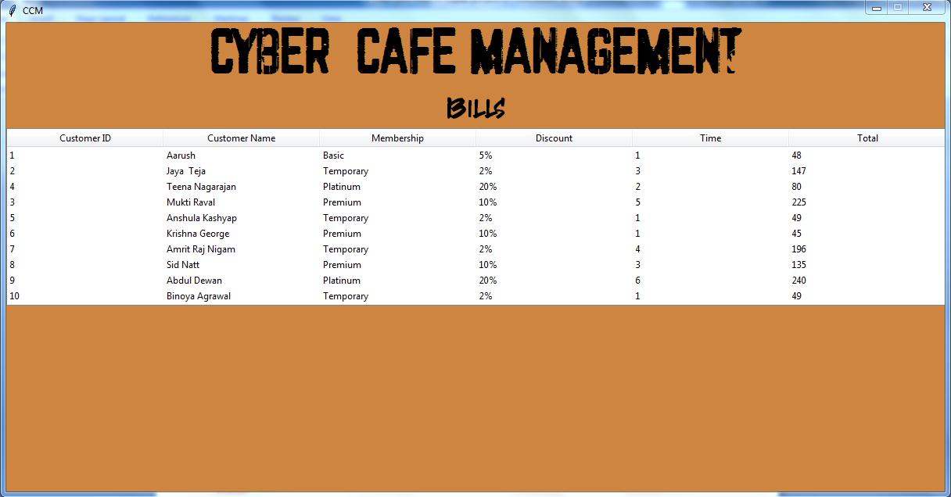

BIBLOGRAPHY

1. https://pyhtontrends.wordpress.com
2. https://shrutipgtcs.wordpress.com
3. Computer Science with Python textbook class 12th by Sumita Arora
4. http://Pythonclassroomdiary.wordpress.com
5. https://Python.org